**Lab 03:**

**Improved Web Design using CSS/Bootstrap**



**Spring 2023**

[**CSE-403L**](https://classroom.google.com/u/0/c/NTk1NjYwNDQzNzky) **DBMS Lab**

Submitted by: **SAQLAIN AHMAD**

Registration No.: **20PWCSE1893**

Class Section: **A**

“On my honor, as student of University of Engineering and Technology, I have neither given nor received unauthorized assistance on this academic work.”

Student Signature:

Submitted to:

**Ma’am Sumayyea Salahuddin**

Friday, March 10th, 2023

**Department of Computer Systems Engineering**

**University of Engineering and Technology, Peshawar**

**Lab 03:**

**Improved Web Design using CSS/Bootstrap**

**OBJECTIVES OF THE LAB**

**This lab aims at the understanding of:**

* The concept of Dynamic HTML
* Cascaded Style Sheets (CSS)
* Various attributes of CSS such as font, color, background, text, border, margin, and list
* User-Defined Selectors including Class and ID
* Span and Div Tags
* External Style Sheets and their benefits.

**---------------------------Task 3.2---------------------------**

**Write the HTML code that generates the output web page shown in Figure 3.9 with following specification:**

**1) Heading 1 has font value of Garamond, size 26 pts, and red color.**

**2) Set top margin to 5%.**

**3) Create unordered list with values: HTML, JavaScript, CGI, Java, Oracle Developer 2000, and Oracle DBA. Use square list style type.**

**Code**

<head>

    <title>Task 2</title>

</head>

<body>

    <div style="margin-top: 5%;">

    <h1 classname="header" style="color: red; font-size: 26px; font-family:Garamond">Silicon Chip Technologies</h1>

        <p> SCT provides Corporate Training for the following products </p>

<ul style="list-style-type: square;">

    <li>HTML</li>

    <li>Javascript</li>

    <li>CGI</li>

    <li>Java</li>

    <li>Oracle Developer 2000</li>

    <li>Oracle DBA</li>

</ul>

</div>

</body>

</html>

**---------------------------Task 3.3---------------------------**

**Write the HTML code along with CSS file that generates the output web page shown in Figure 3.9.**

**Code (HTML)**

<head>

    <title>Task 3</title>

<link rel="stylesheet" href="task3.css" >

</head>

<body>

    <div class="container">

    <h1 class="header">Silicon Chip Technologies</h1>

        <p> SCT provides Corporate Training for the following products </p>

<ul>

    <li>HTML</li>

    <li>Javascript</li>

    <li>CGI</li>

    <li>Java</li>

    <li>Oracle Developer 2000</li>

    <li>Oracle DBA</li>

</ul>

</div>

</body>

</html>

**Code (External CSS)**

.container{

    margin-top: 5%;

}

.header{

    color: red;

    font-size: 26px;

    font-family: Garamond;

}

.container li{

    list-style: square;

}

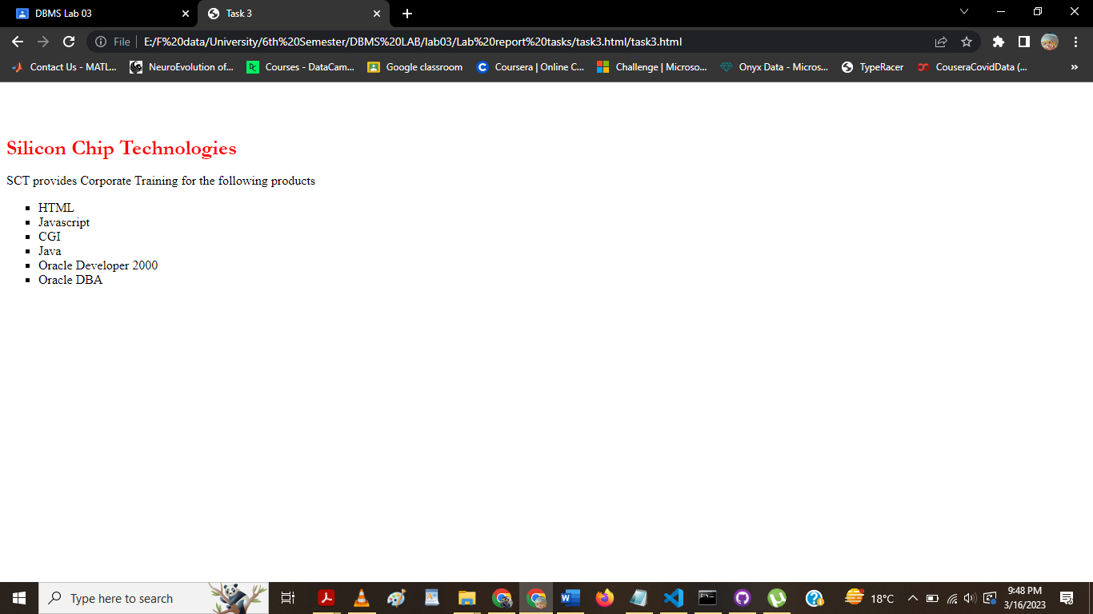

**---------------------------Task 3.4---------------------------**

**Rewrite Example 5 using ID Selector instead of class Selector and show its output.**

**Code**

<html>

 <head>

 <title> Use of Margin Attributes </title>

 <style type="text/css">

#question{

    color: brown; font-style: italic;

}

#answer{

    color:#23238e

}

#question2{

    color: brown; font-style: italic;

}

#answer2{

    color:#23238e

}

 p {font-size:12pt;

 font-weight:bold;

 text-align:justify;

 margin-left:10%;

 margin-right:10%;}

 </style>

 </head>

 <body>

 <p id="question">How to create style sheet to alter an HTML

 element?</p>

 <p id="answer">The Style assignment process can be accomplished with

 the &lt;STYLE&gt;...&lt;/STYLE&gt; tags. The syntax for making the

assignment is simple. Between &lt;STYLE&gt; and &lt;/STYLE&gt;, HTML tags

 to which styles are to be assigned are to be listed ad each tag with a pair of

 curly brackets in which specific style attributes are to be specified. This

 &lt;STYLE&gt; tag should be within &lt;HEAD&gt;...&lt;/HEAD&gt;

 element.</p>

 <br>

 <p id="question2">What are the attributes that can be specified? </p>

 <p id="answer2">The attributes that can be specified are: Font attributes,

 Color and Background attributes, Text attributes, Border attributes, Margin

 attributes, and List attributes. </p>

 </body>

 </html>

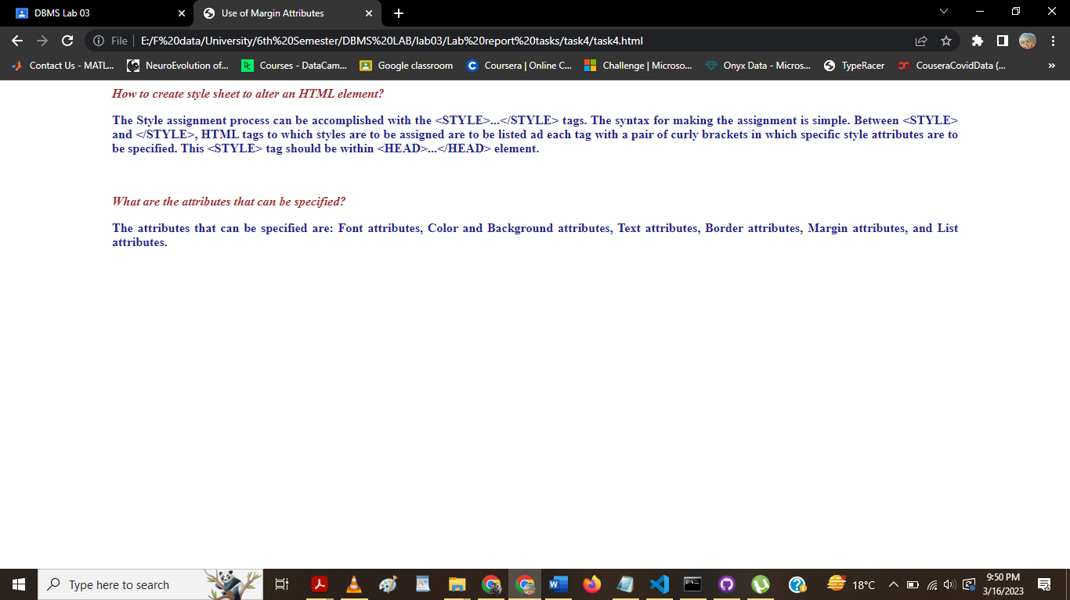

**---------------------------Task 3.5---------------------------**

**Bootstrap 5.2.3 Examples:**

**Go through the following examples in bootstrap-5.2.3-examples.zip file provided with Lab 01: sign-in, cover, checkout, and blog. Modify these examples for a real-world application. Submit the modified web pages and respective HTML and CSS files with description.**

**Code**

**---------------------------Task 3.6---------------------------**

**Modify your CV designed using plain HTML in last lab by adding CSS and Bootstrap in it. Upload both original one and modified one on the hosting site. Provide the link.**

**Link:** <https://EngineerSaqlain.github.io/EngineerSaqlain.CSS.github.io/>

**Code (HTML)**

<html>

    <link rel="icon" type="image/x-icon"

        href="https://media.licdn.com/dms/image/D4D03AQHlewSrXO8vuA/profile-displayphoto-shrink_800_800/0/1668574069397?e=2147483647&v=beta&t=rhepN5ZPoNQBj4Ha0Z34s0CWN86AK2xVZmFguHoZuA0">

    <link rel="stylesheet" href="style.css">

    </head>

<body>

    <img src="user.png">

    <h1>Name XYZ</h1>

    <h2>Contact</h2>

    <p><b>Email id:</b>xyz@gmail.com</p>

    <p><b>Mobile no :</b>1234567890</p>

    <h2>Skills</h2>

    <ul>

        <li><b>Programming Languages :

                Python, C, C++</b></li>

        <li><b>Frontend : HTML5, CSS3,

                React</b></li>

        <li><b>Backend : NodeJS</b></li>

    </ul>

    <h2>Language</h2>

    <p>English</p>

    <p>Urdu</p>

    <h2>Hobbies</h2>

    <p>Reading</p>

    <p>Reading</p>

    <p>Web Developer</p>

    <h2>Summary</h2>

    <p>To gain experience in numerous projects where I can implement my creativity in different phases of my life.

    </p>

    <h2>Experience</h2>

    <h3>ABC Company- Intern Web Developer</h3>

    <p>January 2023 to Present</p>

    <p>Managed Web Projects for the company</p>

    <h3>XYZ Company - intern web developer</h3>

    <p>August 2022 to December 2022</p>

    <p>Managed Web Projects for the company</p>

    <h2>Education</h2>

    <table class="edata">

        <tr>

            <th>University/college</th>

            <th>Passing year: 2020 </th>

            <th>Grade</th>

        </tr>

        <tr>

            <td>abc</td>

            <td>2020</td>

            <td>A grade</td>

        </tr>

        <tr>

            <td>pqr</td>

            <td>2018</td>

            <td>A grade</td>

        </tr>

    </table>

            <h2>Project1</h2>

            <p>This project is built with HTML</p>

            <h2>Project2</h2>

            <p>This project is based on wordpress</p>

</body>

</html>

**Code (External CSS)**

*{

    background-color: blueviolet;

    text-align: center;

}

* img{

    width: 100;

    height: 100;

    border: solid;

    border-radius: 50%;

}

* ul{

    list-style: none;

}

.edata{

    border: 1px;

    border-style: double;

    margin-left: 40%;

}

* h2{

    text-decoration: underline;

    font-family: 'Lucida Sans', 'Lucida Sans Regular', 'Lucida Grande', 'Lucida Sans Unicode', Geneva, Verdana, sans-serif;

}

The End